|  |
| --- |
| Embedded Systems Lab Experiment 5 |
| Waveform Generation in ATMega 32 microcontroller |
| Program an ATMega32 to output different waveforms using DAC |

|  |
| --- |
| Jitbitan Baroi  2-29-2024 |

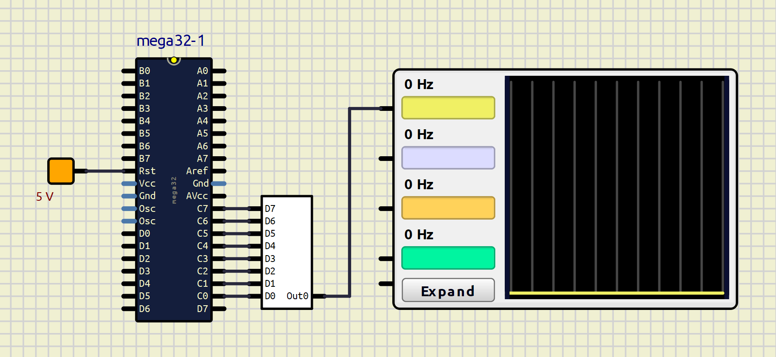

Schematic used for Assignment 1,2,3

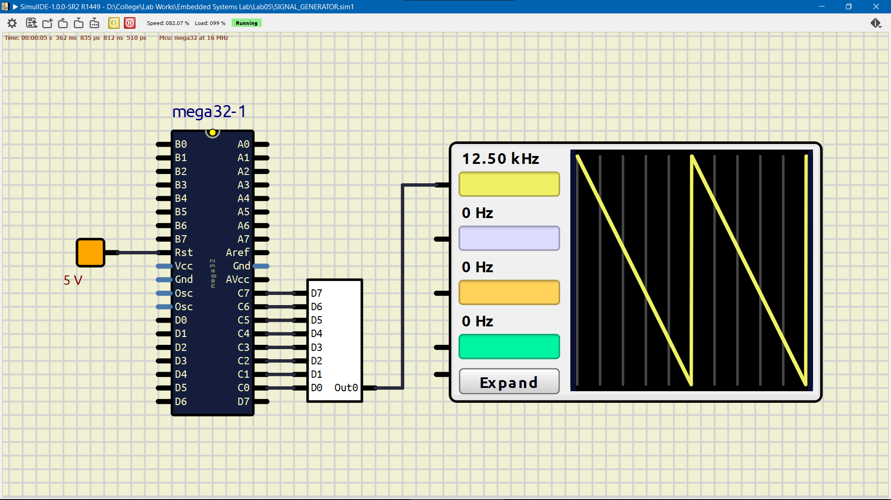

Simulation of the 1st assignment

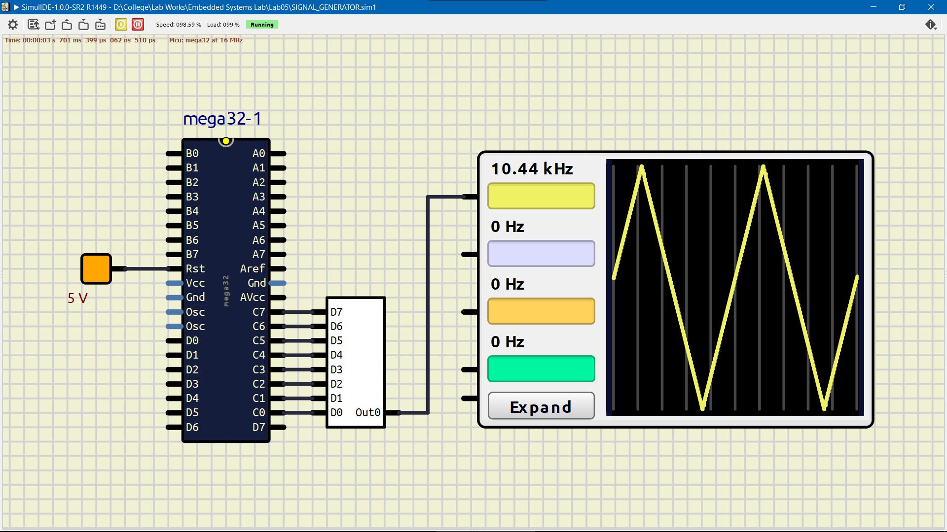

Simulation of the 2nd assignment

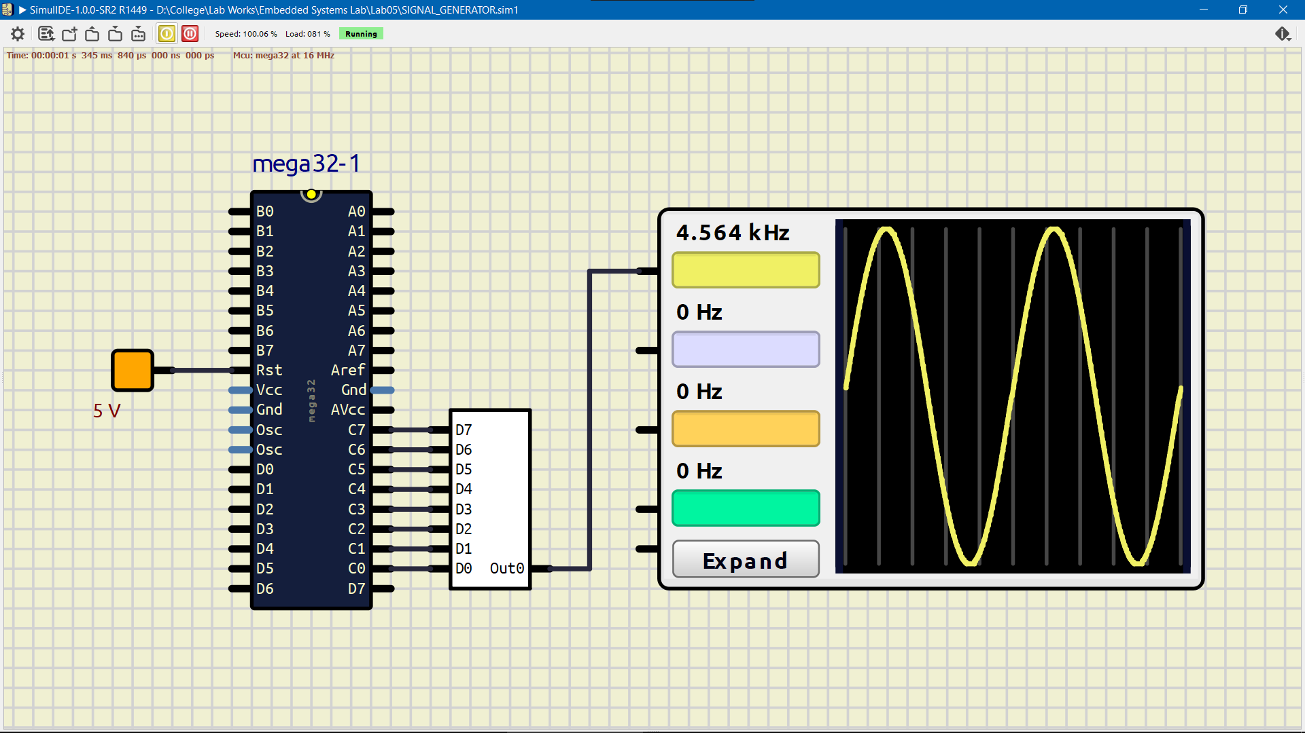

Simulation of the 3rd assignment